1.

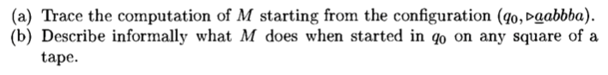

2.



